
Software Engineering

Department of Software Engineering

Students:
BABAR SALEEM SE-9244363
Section:
BSSE-2B-Mor
Deliverable no:
3

Smart Learn
[Company name] | [Company address]

Smart Learn

Functional Requirements:
- The system allows users to upload and download study notes and books.
- The system shall allow users to create or join discussion rooms for academic collaboration.
- The system allows users to interact with an AI helper to ask questions and receive educational assistance.
- The system shall allow users to set and receive reminders for deadlines such as assignments and exams.
- The system allows users to securely register and log in to access their personalized learning environment.
- The system allows users to organize and categorize study resources based on subjects and topics.

Non-Functional Requirements:
- The system should be user-friendly and intuitive for users of varying technical skills.
- The system shall be responsive, with page load times not exceeding 2 seconds.
- The system should be scalable to support a growing number of users and uploaded content.
- The system should be secure to protect user data through encryption and safe authentication methods.
- The system will be reliable with an uptime of at least 99%.
- The system should be maintainable, with modular code allowing easy updates and debugging

System Requirements
Hardware Requirements:
- Processor: Minimum 1.5 GHz (dual-core or higher)
- RAM: At least 4 GB
- Storage: Minimum 500 MB of free space
- Input: Touchscreen (mobile/tablet)
Software Requirements
- Operating System:
- Mobile: Android 9 or later, iOS 12 or later
Network Requirements
- Internet Connection: Minimum 2 Mbps for smooth usage
- Network Type: Wi-Fi or Mobile Data (4G recommended
- Latency: Less than 150ms for optimal discussion and AI response experience

User Tasks
- As a user, I want to log in securely so that my personal data and learning progress are protected.
- As a user, I want to upload and download study notes and books so that I can share and access useful learning materials.
- As a user, I want to join or create discussion rooms so I can collaborate and communicate with other students.
- As a user, I want to ask questions to an AI helper so I can quickly get explanations and answers related to my studies
- As a user, I want to set reminders for my deadlines so I can keep track of upcoming assignments and exams.
- As a user, I want to search and organize study materials by subject or topic so I can study more efficiently and find what I need quickly.

UML Diagram
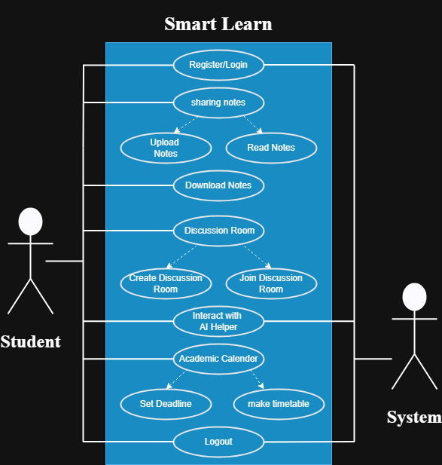

Activity Diagram
